Social Media copy
Bowel Screening Campaign

Age Group | Messaging | Creative
56 year olds | Did you know that bowel cancer is the 4th most common type of cancer?  Screening can help find it at an early stage, when it’s easier to treat.  If you’re aged 56 you can now do your bowel cancer screening.  Find out more here www.nhs.uk/conditions/bowel-cancer-screening/ |   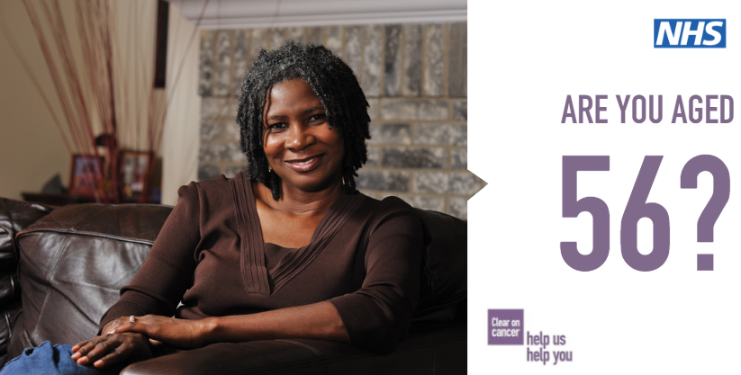    
56 year olds | Are you aged 56?  You will receive a bowel cancer screening kit in the post. This simple test will help find bowel cancer earlier when it’s easier to treat.  To find out more click here: www.nhs.uk/conditions/bowel-cancer-screening/
56 year olds | Have you been sent your bowel cancer screening kit in the post?  If you are aged 56, or over 60 you can do your screening.  Cancer won’t wait. Screening can help find bowel cancer at an early stage, when it’s easier to treat.  More info here: www.nhs.uk/conditions/bowel-cancer-screening/ | 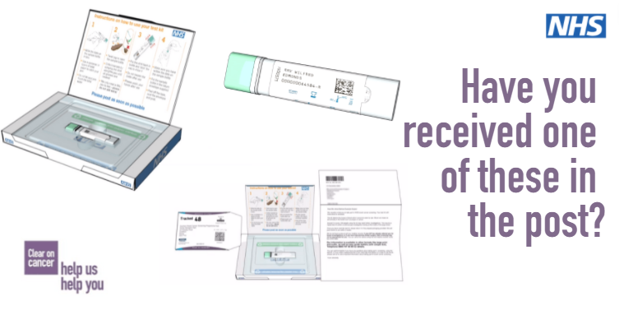
Age Group | Messaging | Creative
58 year olds | Did you know that bowel cancer is the 4th most common type of cancer?  Screening can help find it at an early stage, when it’s easier to treat.  If you’re aged 58 you can now do your bowel cancer screening.  Find out more here www.nhs.uk/conditions/bowel-cancer-screening/ | 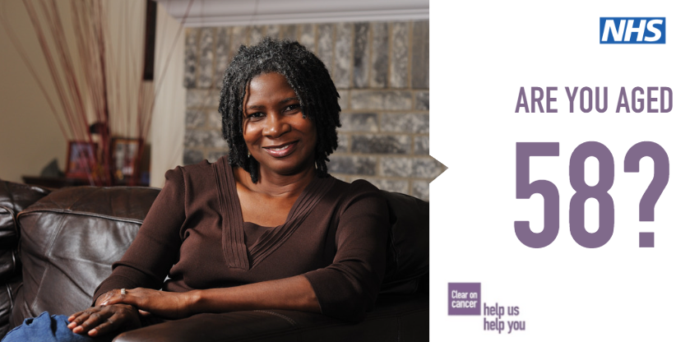
58 year olds | Are you aged 58?  You will receive a bowel cancer screening kit in the post. This simple test will help find bowel cancer earlier when it’s easier to treat.  To find out more click here: www.nhs.uk/conditions/bowel-cancer-screening/
58 year olds | Have you been sent your bowel cancer screening kit in the post?  If you are aged 58 you can do your screening.  Cancer won’t wait. Screening can help find bowel cancer at an early stage, when it’s easier to treat.  More info here: www.nhs.uk/conditions/bowel-cancer-screening/

