Junior doctors strike social media copy

Schedule date | Message | Asset(s) | Supporting Copy
From Thursday/Friday | Repeat prescriptions | 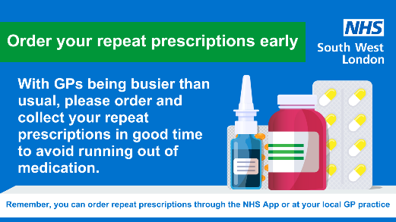 | 📣 Do you take medication regularly?  ⌛ With upcoming strike action, GPs will be busier than usual, it’s important to check your prescription and order what you need and in plenty of time.
From Thursday/Friday | Continue to attend scheduled appointments next week | 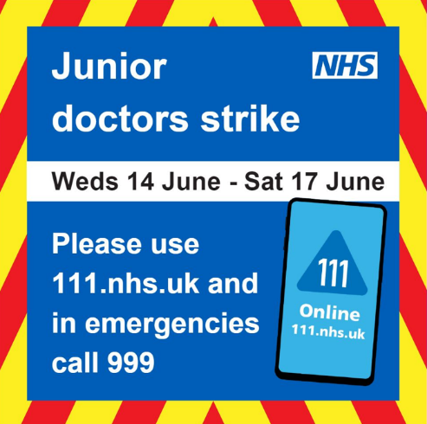 | 📣 Junior doctors strike action next week is expected to cause major disruption – but the NHS is still here for people who need care  💻Please use 111.nhs.uk, and in emergencies, call 999.
Monday 12 June onwards | Continue to attend scheduled appointments | 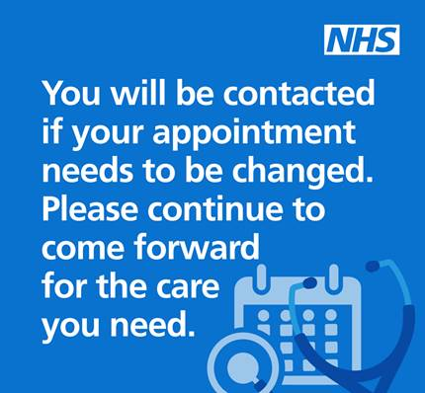 | 📣 With strike action taking place across the country, the NHS is still here for people who need care –  you will be contacted if your appointment needs to be changed.  💻 Please 111.nhs.uk, and in emergencies, call 999.
Monday 12 June onwards | Use 111 online if not life threatening, 999 emergencies only |  | 📣 Junior doctors strike action this week is expected to cause major disruption – but the NHS is still here for people who need care  💻Please use 111.nhs.uk, and in emergencies, call 999.

