Examples of focus group promotional copy
For social media – an example:
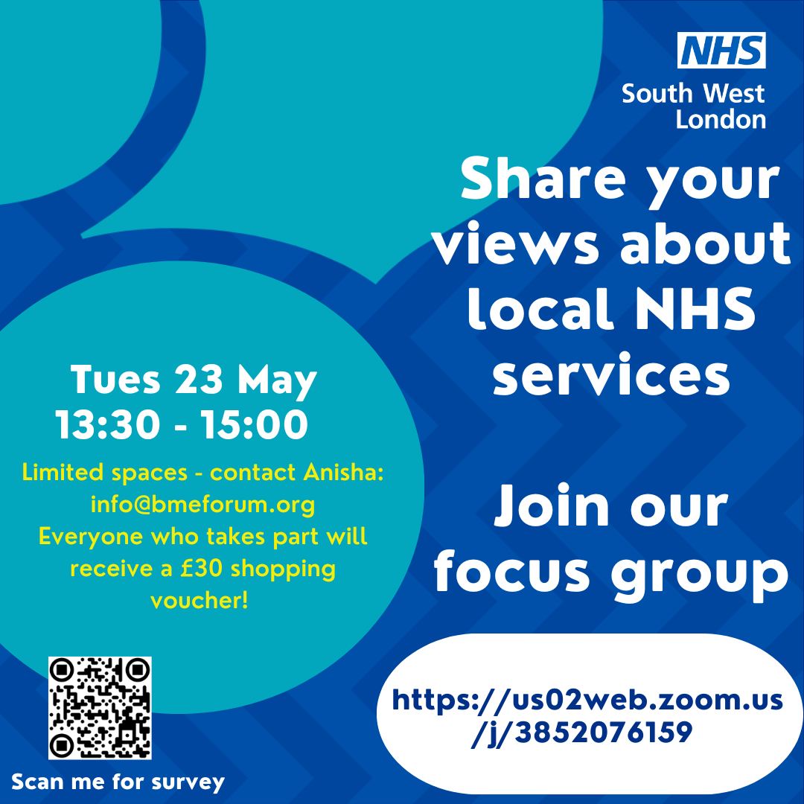

For email or newsletters:
Calling all parents - Has your child had the MMR vaccine? If not, we want to hear from you.

Your thoughts about the MMR vaccine and your reasons for not vaccinating your child are essential to us. Together, we can ensure all parents have the right information to make informed decisions about their children.

Are you:
- a parent of a child who has not had an MMR vaccine
- from a Black African or Black Caribbean community
- living in Croydon. Kingston, Richmond, Sutton, Merton or Wandsworth

Join an online discussion with a local healthcare professional to share your views about the MMR vaccine. You can also ask questions.

The discussion will take place on Microsoft teams on Wednesday 16th August, 1-2pm. To book your place and for more information email ADD EMAIL or call XXXX

If you are unable to access Microsoft Teams and would like to provide your input, please get in touch with Aman Nathan to discuss the best way to share your input.
As a thank you for your contribution, you would receive a £30 voucher for Love2Shop.

Why should I get involved?
We want to understand why some parents might hesitate to vaccinate their children against measles, mumps, and rubella. We want to know more about attitudes towards childhood vaccination, and most importantly, we want to learn what information would help parents to make an informed choice.

How will your feedback help us? Your feedback will help to ensure that every parent has access to the best information about the MMR vaccine and other childhood immunisations.
